July 27, 2020
Managua, Nicaragua

Your Excellency
Bob Loughman Weibur
Prime Minister of the Republic of Vanuatu
Port Vila

Dear Prime Minister,

On behalf of the People and Government of Reconciliation and National Unity of the Republic of Nicaragua, and on our own behalf, we wish to express our Congratulations to You, the People and the Government of the Republic of Vanuatu, on the occasion of commemorating the 40th Anniversary of your Independence, which will be celebrated under the theme “Prosperity for Self-Reliance and a Resilient Future” on July 30.
Excellency,

On this solemn occasion, we take the opportunity to recognize your commitment to achieve Peace, Prosperity and Well-being for your People, ideals that we share as Free and Sovereign Nations.

The Government of Reconciliation and National Unity of the Republic of Nicaragua wishes to reiterate its will to continue strengthening the Bonds of Friendship, Solidarity and Cooperation that unite our Peoples and Governments.

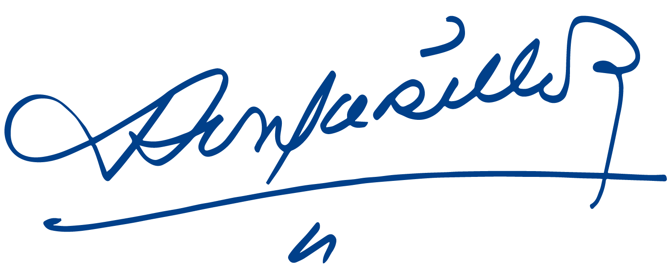
Please receive the fraternal embrace from our Always Blessed and Always Free Nicaragua.


Daniel Ortega Saavedra Rosario Murillo

