August 29, 2020
Managua, Nicaragua

Your Excellency
Zuzana Čaputová
President of The Slovak Republic
Bratislava

Dear President,

On behalf of the People and Government of Reconciliation and National Unity of the Republic of Nicaragua, and on our own behalf, we wish to express our most sincere congratulations to You, the People and the Government of The Slovak Republic, for Commemorating the 28th Anniversary of the Day of the Constitution, this coming September 1.
On this solemn date, we send our fraternal greetings to the People and Government of the Slovak Republic, on the occasion of celebrating your National Holiday, reiterating our will to continue strengthening the Bonds of Friendship and Solidarity between our Peoples and Governments and transmitting our best wishes for the Health, Peace and Prosperity for the Brotherly People of Slovakia.

Madam President, receive from our Always Blessed and Always Free Nicaragua, the Fraternal Embrace, as well as the affection and appreciation of all Nicaraguans.

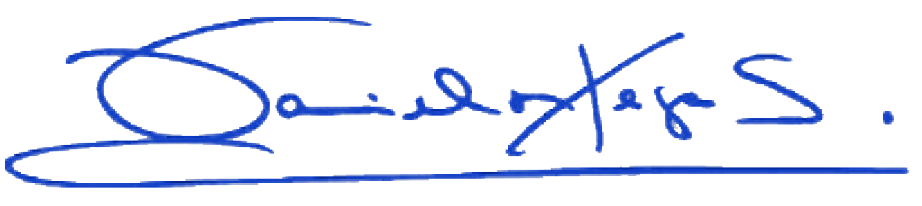
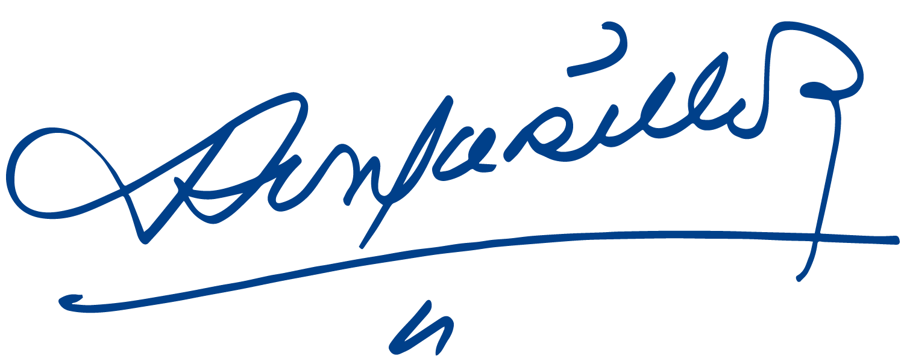

Daniel Ortega Saavedra Rosario Murillo

