Managua, August 11, 2020

Your Excellency
Brother Keith Rowley
Prime Minister of Trinidad and Tobago
Port of Spain

Brother Prime Minister:

With Fraternal Solidarity we celebrate your Triumph yesterday, Monday, August 10, which accredits and confirms You and your Party, the People’s National Movement (PNM), for a New Mandate to lead and accompany your People, in these complex Times, with Stability, Work, Health and Peace.

Allow us Brother, Your Excellency Prime Minister, to greet You on behalf of our People, ratifying our commitment to continue strengthening the Ties of Fraternal Unity for the Common Good, in this Our Caribbean America that we all wish of Well-being, Development, Security and Peace.

We are sure also, that in the International Forums we will be working together for a World of Dialogue, Rights and Fair and Harmonious Development, for all Peoples.

Again, our consideration and esteem,
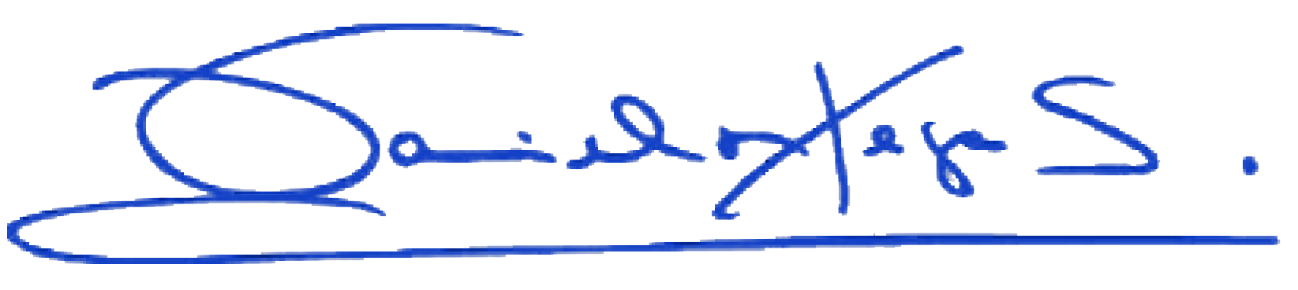
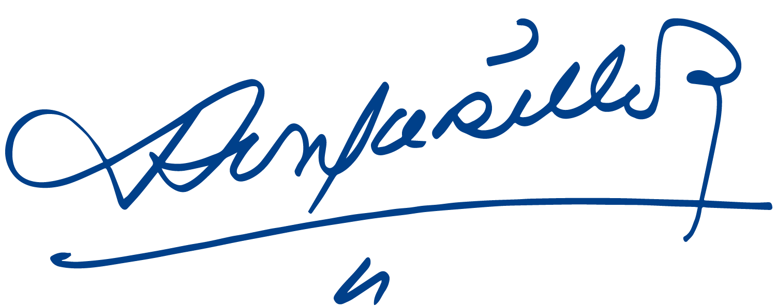

Daniel Ortega Saavedra Rosario Murillo

