Managua, August 16, 2020

Your Excellency
Joko Widodo
President of the Republic of Indonesia
Jakarta

Dear Mr. President,

On behalf of the People and Government of Reconciliation and National Unity of the Republic of Nicaragua, and on our own behalf, we wish to express our Congratulations to You, the People and Government of the Republic of Indonesia, on the occasion of commemorating the 75th Anniversary of Independence, this next August 17.
Excellency,

On this solemn occasion, the Government of Reconciliation and National Unity of the Republic of Nicaragua wishes to reiterate its will to continue strengthening the Bonds of Solidarity and Cooperation that unite our Peoples and Governments.

Receive the Fraternal Embrace from our Always Blessed and Always Free Nicaragua.


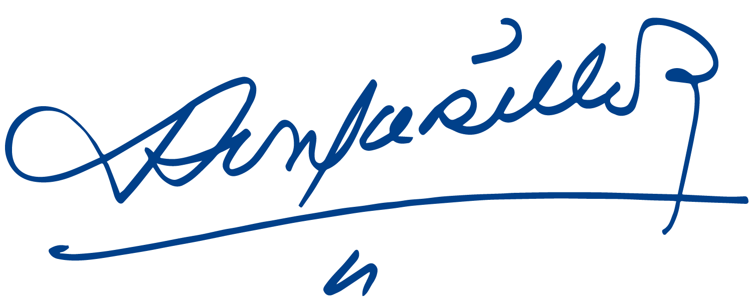

Daniel Ortega Saavedra Rosario Murillo

