September 4, 2020
Managua, Nicaragua

Your Excellency
Emomali Rahmon
President of the Republic of Tajikistan
Dushanbe

Dear President,

On the solemn occasion of commemorating the 29th Anniversary of Independence of the Republic of Tajikistan this September 9, we wish to express, on behalf of the People and Government of Reconciliation and National Unity of the Republic of Nicaragua, and on our own behalf, our Congratulations to You, Your People and Government.
Excellency,

The Government of Reconciliation and National Unity of the Republic of Nicaragua avails itself of this opportunity to reiterate its Will to continue strengthening the Bonds of Friendship, Solidarity and Cooperation that unite our Peoples and Governments.

From our Always Blessed and Always Free Nicaragua, please receive our Fraternal Embrace, as well as the affection of all Nicaraguans for the Brotherly People of Tajikistan.


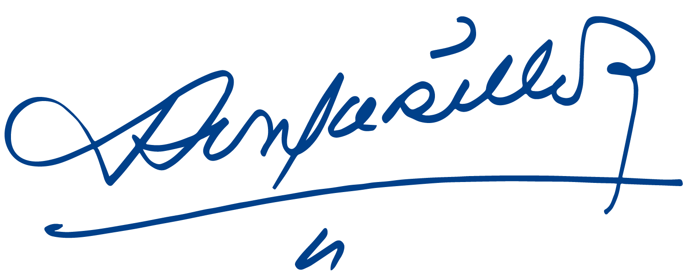
Daniel Ortega Saavedra Rosario Murillo

