September 14, 2020
Managua, Nicaragua

Your Excellency
Khadga Prasad Sharma Oli
Prime Minister of the
Federal Democratic Republic of Nepal
Kathmandu

Dear Prime Minister,

On behalf of the People and Government of Reconciliation and National Unity of the Republic of Nicaragua, and on our own behalf, we wish to express our Congratulations to You, the People and the Government of the Federal Democratic Republic of Nepal, on the occasion of commemorating the 5th Anniversary of the Constitution Day, this upcoming September 20.
On this solemn occasion, we take the opportunity to recognize your commitment to achieving Peace, Well-being and Development of your People, ideals that we share as Free and Sovereign Nations.

Dear Prime Minister,

The Government of Reconciliation and National Unity of the Republic of Nicaragua wishes to reiterate its will to continue strengthening the Bonds of Friendship, Solidarity and Cooperation that unite our Peoples and Governments.

From our Always Blessed and Always Free Nicaragua, please receive our Fraternal Embrace, as well as the affection of all Nicaraguans for the Brotherly People of Nepal.
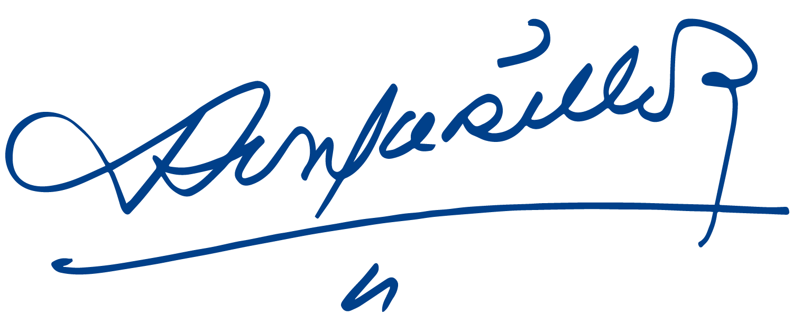
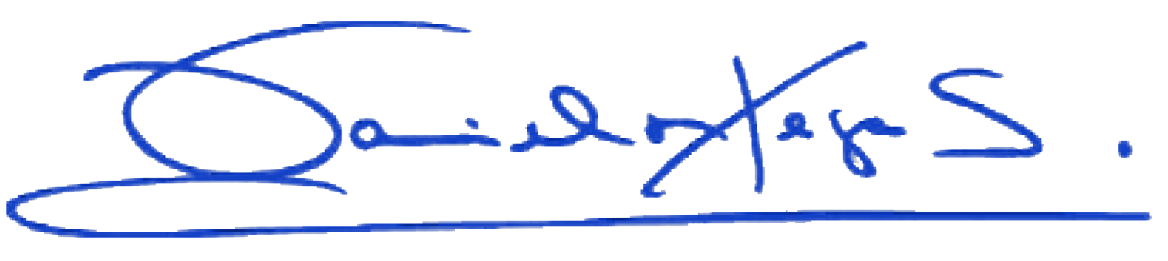

Daniel Ortega Saavedra Rosario Murillo

