Managua, September 4, 2020

Comrade
Kim Jong-un
Supreme Leader of the Korean People
Chairman of the Workers Party of Korea
President of the State Committee
of the People's Democratic Republic of Korea
and Supreme Commander of the Armed Forces
of the DPR of Korea
Pyongyang

Comrade Kim Jong-un:

On September 9, 1948, 72 years ago, a People's Assembly proclaimed the People's Democratic Republic of Korea, designating as Prime Minister,
the Historical Leader of your Great People, Comrade Kim Il-sung.

With great appreciation and admiration for the Historical Achievement of a Country that fought admirably for its Culture, its Way of Life and its Full Independence, we salute this 72nd Anniversary, with recognition for the Firmness and Heroism that allowed the Citizens of the People's Democratic Republic of Korea to strengthen Historical Processes, affirming the Respect that all Peoples deserve, and we owe to each other, from Principles and Values that Humanity proclaims and demands: Respect, Peace with Justice; Security, Rights; Dignity, Prosperity, and the inescapable Responsibility to share a World of Dialogue, Coexistence and Goodwill for All.

As we greet the Brotherly Korean People, we evoke the Memory of the Great Leader, Comrade Kim Il-sung, whom we had the Privilege and Honor to meet and visit, in Pyongyang, in historical visits, the first, in the week of March 21 1983, in our Year of "Struggle for Peace and Sovereignty." (And we keep fighting!), and also, in September 1986.

We also evoke the Memory and Legacy of his son and successor, Leader and President, Comrade Kim Jong-il. And we express our consideration and esteem to You, Comrade Chairman of the Korean Workers Party, Chairman of the State Committee of the Democratic People's Republic of Korea, and Supreme Commander of the Armed Forces of the Democratic People's Republic of Korea, Comrade Kim Jong-un.

From our Blessed and Always Free Nicaragua, again, on this 72nd Anniversary, our admiration and affection, to the Families of that Heroic People, with the Fraternal Embrace of the Families and the People of Darío and Sandino.

We fight for Peace!
We fight for a Fair, Respectful, Better World!
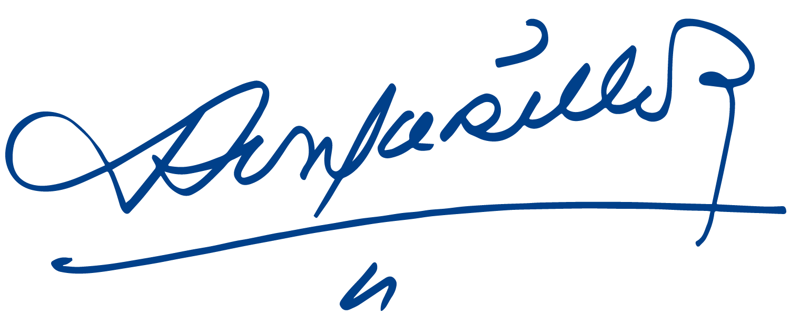
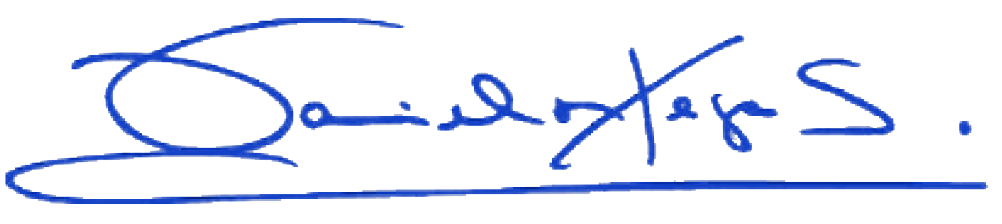

Daniel Ortega Saavedra Rosario Murillo

