September 4, 2020
Managua, Nicaragua

Your Majesty
Mswati III
Kingdom of Eswatini
Mbabane

Your Majesty,

On behalf of the People and Government of Reconciliation and National Unity of the Republic of Nicaragua, and on our own behalf, we wish to express our congratulations to You and the People of the Kingdom of Eswatini, on the occasion of commemorating the 52nd Anniversary of Independence, this September 6.

Majesty,

On this solemn occasion, we take the opportunity to recognize your commitment to achieving Peace, Well-being and Development of your People, ideals that we share as Free and Sovereign Nations.

The Government of Reconciliation and National Unity of the Republic of Nicaragua wishes to reiterate its will to continue strengthening the Bonds of Friendship, Solidarity and Cooperation that unite our Peoples.

From our Always Blessed and Always Free Nicaragua, please receive our Fraternal Embrace, as well as the affection of all Nicaraguans for the Brotherly People of Eswatini.
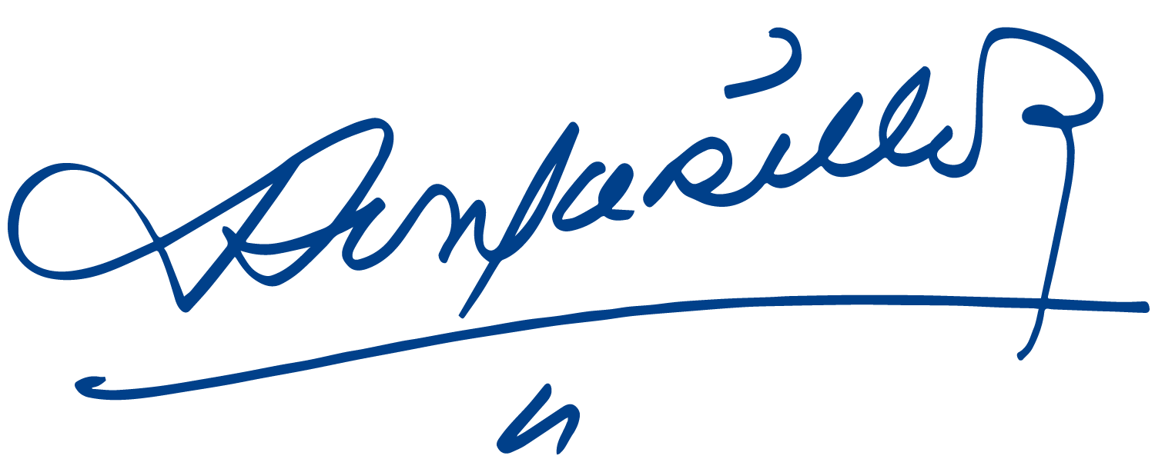


Daniel Ortega Saavedra Rosario Murillo

