September 26, 2020
Managua, Nicaragua

Your Excellency
Nikos Anastasiadis
President of the
Republic of Cyprus
Nicosia

Dear President,

On behalf of the People and Government of Reconciliation and National Unity of the Republic of Nicaragua, and on our own behalf, we wish to express our most sincere congratulations to You, the People and the Government of the Republic of Cyprus, for commemorating the 60th Anniversary of Independence, this coming October 1.

On this special occasion, we convey a Fraternal Greeting and our best wishes for Health, Prosperity and Peace to the People and Authorities of the Republic of Cyprus, as you celebrate your Feast of Independence.

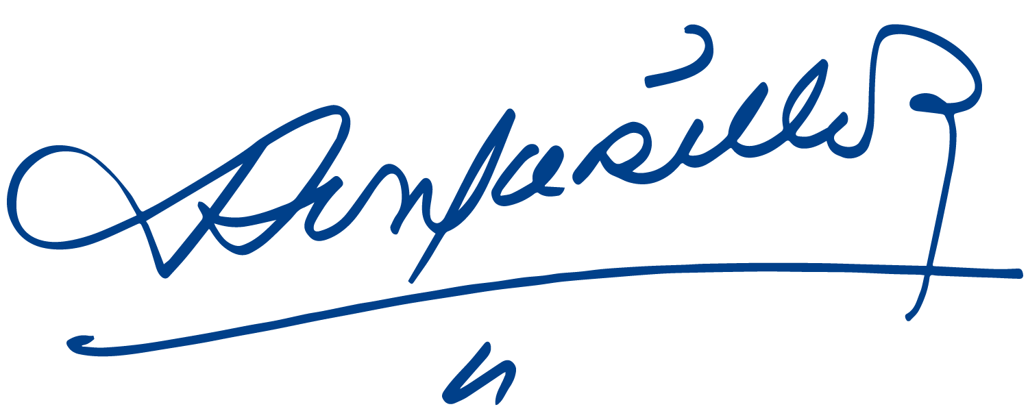
Receive the Fraternal Embrace from Our Always Blessed and Always Free Nicaragua, with the love and appreciation of all Nicaraguans for the Brotherly People of Cyprus.


Daniel Ortega Saavedra Rosario Murillo

