October 24, 2020
Managua Nicaragua

Your Excellency
Miloš Zeman
President of the Czech Republic
Prague

Dear Mr. President,

On behalf of the People and Government of Reconciliation and National Unity of the Republic of Nicaragua, and on our own behalf, we wish to express our most sincere Congratulations to You, the People and the Government of the Czech Republic, for commemorating the 102nd Anniversary of Independence, this coming October 28.
On this special occasion, we send our Fraternal Greetings to the People and Government of the Czech Republic, in Celebration of their Independence Festivities, along with our best wishes for Health, Prosperity and Peace.

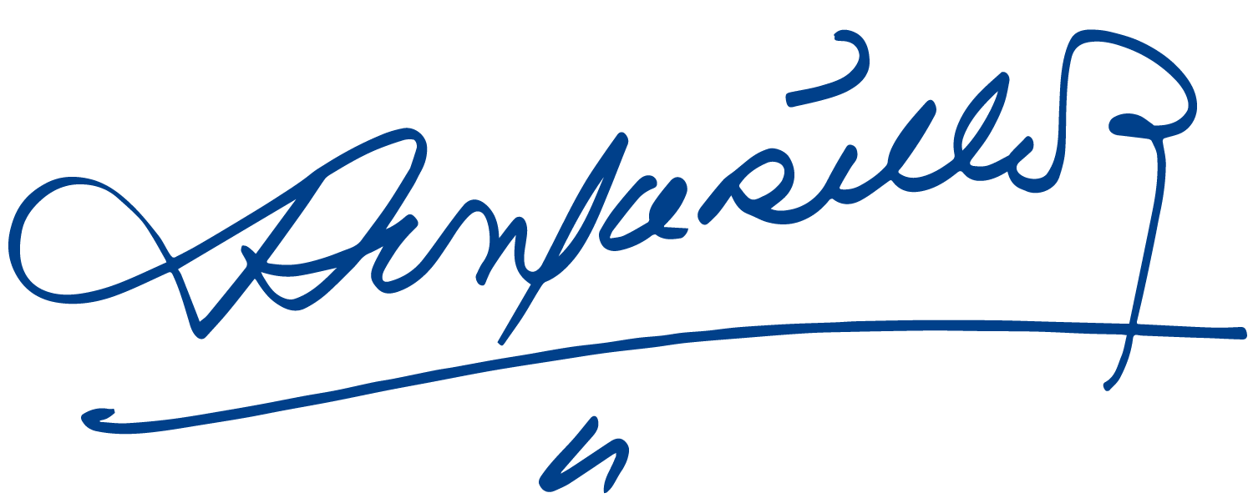
Please receive from our Always Blessed and Always Free Nicaragua, our Fraternal Embrace, with the affection and recognition from all Nicaraguans for the Brotherly People of the Czech Republic.
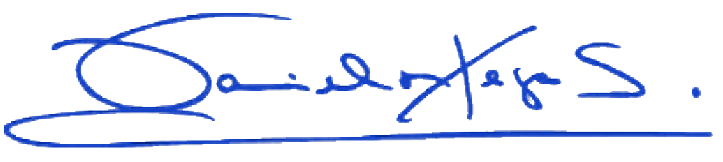

Daniel Ortega Saavedra Rosario Murillo

