October 15, 2020
Managua, Nicaragua

Your Excellency
David Kabua
President of the
Republic of the Marshall Islands
Majuro

Dear President,

On behalf of the People and Government of Reconciliation and National Unity of the Republic of Nicaragua, and on our own behalf, we wish to express our deepest Condolences to You, your People and Government, especially to the beloved family of Iroij Litokwa Tomeing, Former President of the Republic of the Marshall Islands, for his transition to another plane of life on October 12.

At this time of mourning for the People of the Marshall Islands, we trust that you will be able to find Peace and Comfort in the Memory of Iroij Litokwa Tomeing, remembering him for his great Legacy in academia and his laudable efforts on behalf of his People.

From our Always Blessed and Always Free Nicaragua, please receive our Fraternal Embrace, as well as the affection of all Nicaraguans for the Brotherly People of the Marshall Islands.
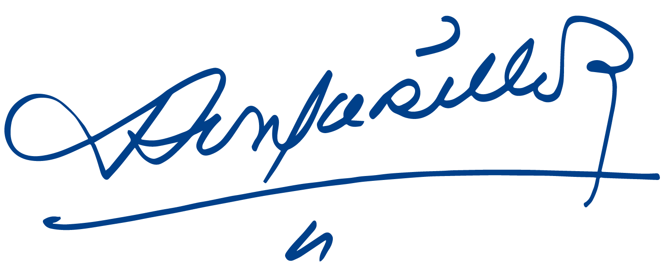


Daniel Ortega Saavedra Rosario Murillo

