October 24, 2020
Managua, Nicaragua

Your Excellency
Dr. Ralph E. Gonsalves
Prime Minister of
Saint Vincent and the Grenadines
Kingstown

Comrade Ralph,

On behalf of the People and Government of Reconciliation and National Unity of the Republic of Nicaragua, and on our own behalf, we wish to convey our warmest Congratulations to You and the Brotherly People and Government of Saint Vincent and the Grenadines, for commemorating the 41st Anniversary of Independence.

Brother Prime Minister,

As we recognize your achievements during these Years of Independence, we are confident that our Nations will continue working together, advocating for a World with Stability and Progress, and promoting the defense of our Ideals, Principles and Purposes in order to achieve unity and development, through mutual cooperation.

Confronting the Great Challenges humanity is facing, the Government of Reconciliation and National Unity of the Republic of Nicaragua wishes to reiterate its unwavering commitment to continue strengthening the Bonds of Caribbean Brotherhood, Fraternity, Solidarity and Cooperation that unite our Peoples and Governments.

We take this opportunity to recognize the achievements of your Government, that under your Firm and Revolutionary Leadership, has led your People on the path of Peace, Prosperity, Wellbeing and International Respect. We are confident, that in the coming days, the People of Saint Vincent and the Grenadines will renew their recognition of Progress and Stability that your Government represents.

From our Always Blessed and Always Free Nicaragua, please receive our most Fraternal Embrace along with the Affection of all Nicaraguans toward the Brotherly People of Saint Vincent and the Grenadines.
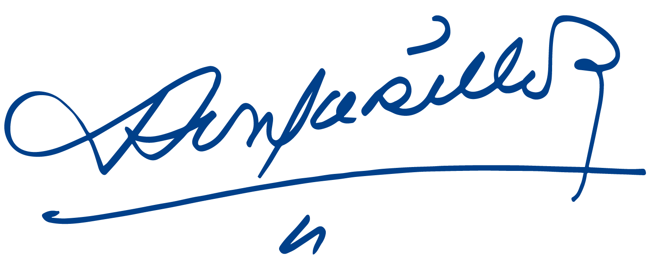
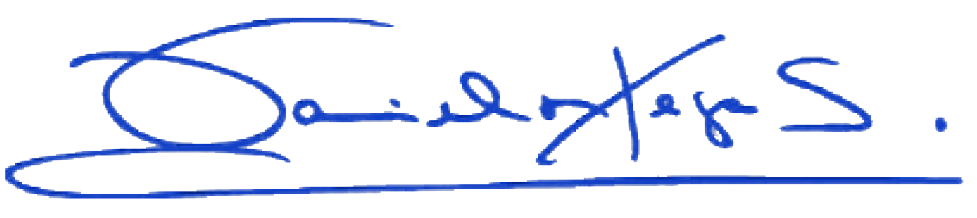

Daniel Ortega Saavedra Rosario Murillo

