September 29, 2020
Managua, Nicaragua

Your Majesty
King Philip I
Kingdom of Belgium
Brussels

Your Majesty,

It is an honor to address Your Majesty on behalf of the People and Government of Reconciliation and National Unity of the Republic of Nicaragua, and on our own behalf, to convey our fraternal Greetings and Congratulations to You and the Brotherly People of the Kingdom of Belgium, for commemorating the 190th Anniversary of Independence, this upcoming October 4.
Your Majesty,

On this historic date, the Government of Reconciliation and National Unity of the Republic of Nicaragua wishes to reiterate its will to continue strengthening the Bonds of Friendship and Solidarity that unite our Peoples, as well as its best wishes for Health, Peace and Prosperity for the Brotherly People of the Kingdom of Belgium and its distinguished authorities.

Receive our Fraternal Embrace from our Always Blessed and Always Free Nicaragua.

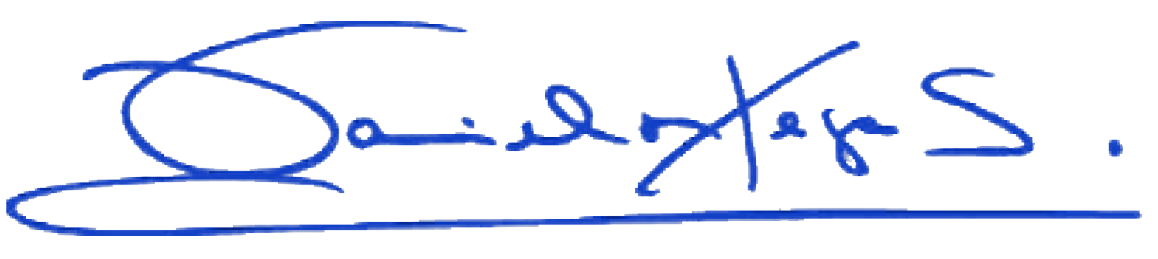
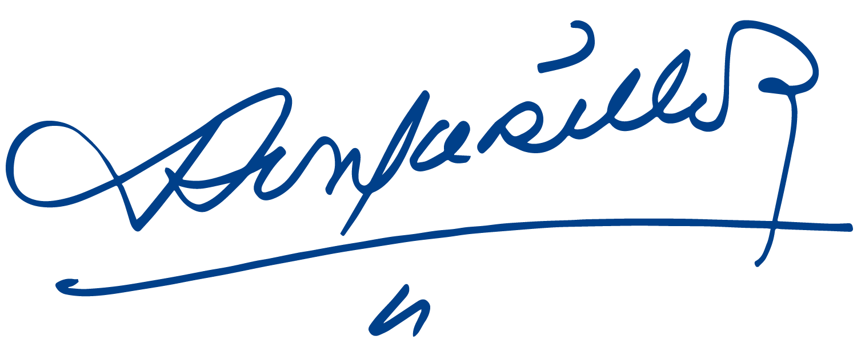
Daniel Ortega Saavedra Rosario Murillo

