Managua, October 31, 2020

Your Excellency
David W. Panuelo
President
Federated States of Micronesia
Palikir

Dear President,

On behalf of the People and Government of Reconciliation and National Unity of the Republic of Nicaragua, and on our own behalf, we wish to express our Congratulations to You, the People and the Government of the Federated States of Micronesia, on the occasion of commemorating the 34th Anniversary of Independence, this upcoming November 3rd.
Dear President,

On this solemn occasion, the Government of Reconciliation and National Unity of the Republic of Nicaragua wishes to reiterate its will to continue strengthening the Friendship and Cooperation that unite our Peoples, as well as its commitment to continue working together, to overcome the great challenges that we face in these times.

From our Always Blessed and Always Free Nicaragua, please receive our Fraternal Embrace, along with the affection of all Nicaraguans for the People of Micronesia.
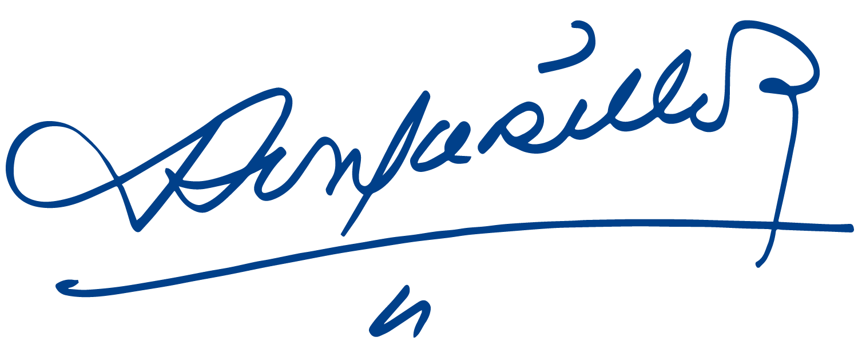
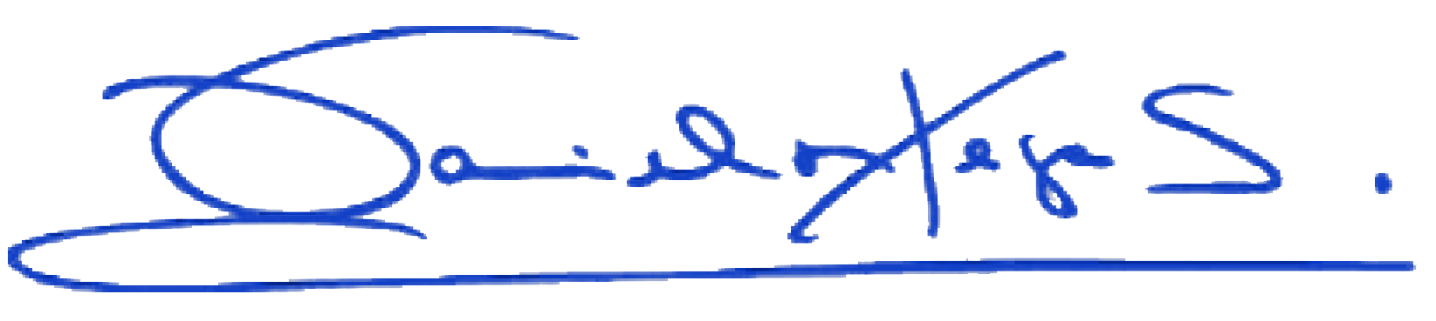
Daniel Ortega Saavedra Rosario Murillo

