Managua, November 28, 2020

Your Excellency
Mohamed Ould Cheikh El Ghazouani
President of the
Islamic Republic of Mauritania
Nouakchott

Dear Brother President,

As you commemorate the 60th Anniversary of the Independence of the Sister Islamic Republic of Mauritania, we wish to express, on behalf of the People and Government of Reconciliation and National Unity of the Republic of Nicaragua, and on our own behalf, our warmest congratulations and our best wishes for good health, happiness and prosperity to You and the Brotherly People and Government of the Islamic Republic of Mauritania.

Brother President,

The Government of Reconciliation and National Unity de Nicaragua reiterates its invariable will to continue strengthening the traditional Bonds of Brotherhood, Solidarity and Cooperation that unite us, as well as its firm commitment to continue working together, to overcome the great challenges of our times.

From our Always Blessed and Always Free Nicaragua, please receive our Fraternal Embrace, as well as the affection of all Nicaraguans for the Brotherly People of Mauritania.

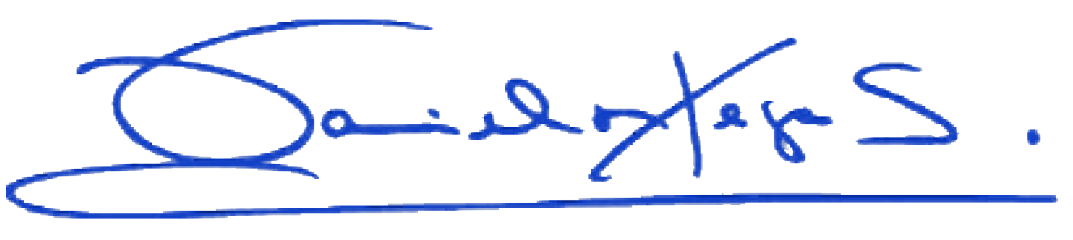
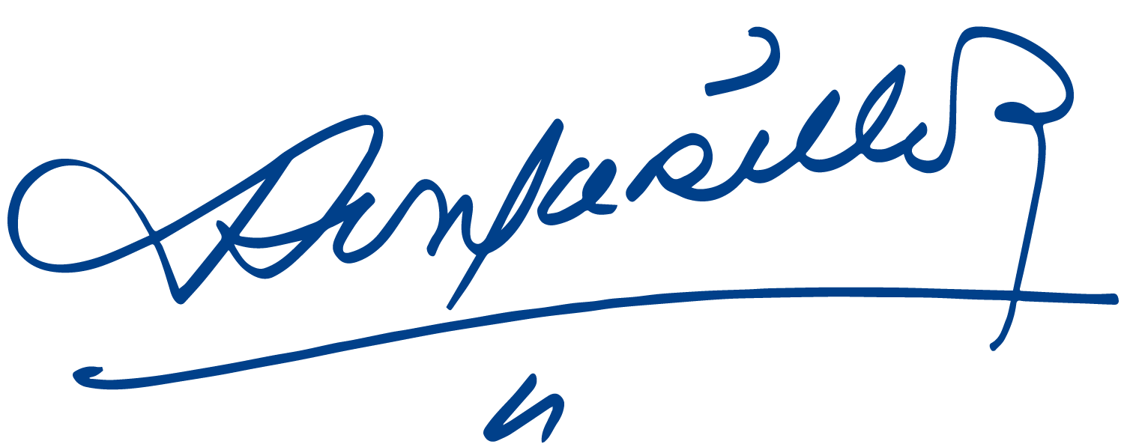
Daniel Ortega Saavedra Rosario Murillo

