Managua, November 28, 2020

Your Excellency
Francisco Guterres
President of the
Democratic Republic of Timor Leste
Dili

Dear President,

On the occasion of commemorating the 45th Anniversary of the Independence of the Democratic Republic of Timor Leste, we wish to express, on behalf of the People and Government of Reconciliation and National Unity of the Republic of Nicaragua, and on our own behalf, our warmest Congratulations to You, the People and Government of the Democratic Republic of Timor Leste.

Dear President,

The Government of Reconciliation and National Unity wishes to reiterate its will to continue strengthening the Bonds of Brotherhood and Solidarity that unite our Peoples, as well as its commitment to continue working together, to overcome the great challenges of our times.

From our Always Blessed and Always Free Nicaragua, receive our Fraternal Embrace, as well as the affection of all Nicaraguans for the Brotherly People of Timor Leste.

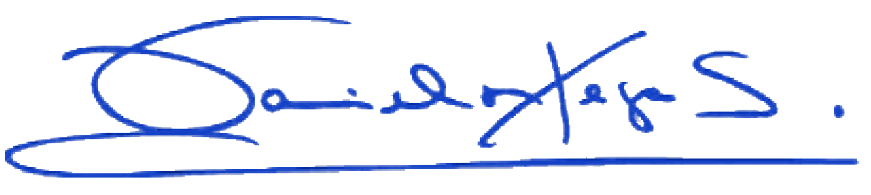
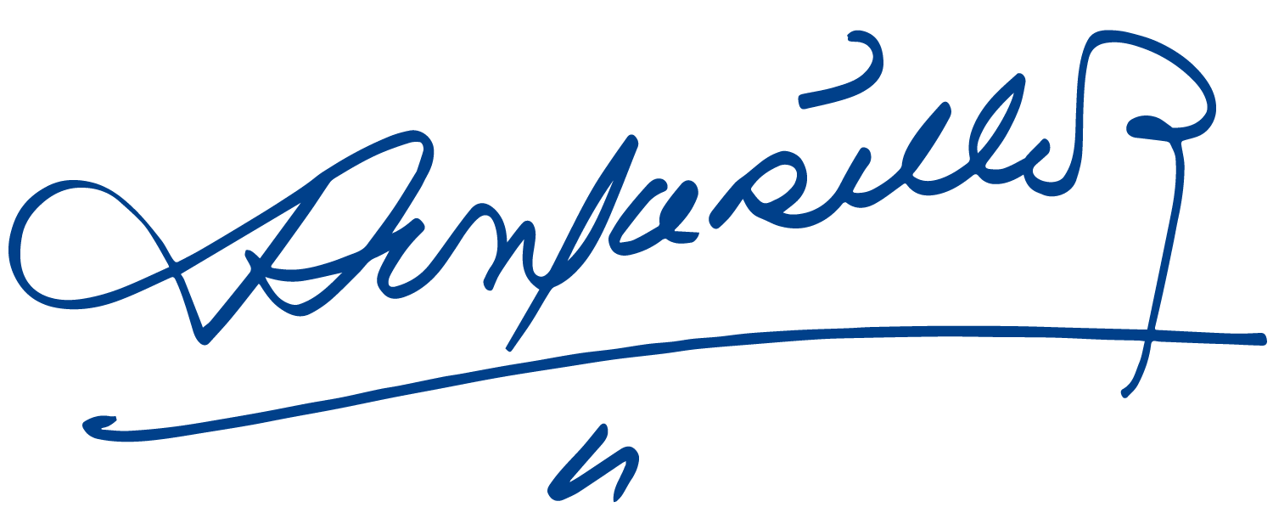
Daniel Ortega Saavedra Rosario Murillo

