Managua, November 7, 2020

Comrade
Mahmoud Abbas
President of the
State of Palestine

Dear Brother President,

We greet you fraternally, on the occasion of expressing on behalf of the Government of Reconciliation and National Unity of the Republic of Nicaragua, and on our own behalf, our warmest Congratulations for commemorating on November 15th, the 32nd Anniversary of the Declaration of Independence of the State of Palestine.

On this memorable and historic date, we always remember the legacy of the Eternal Leader Yasser Arafat and his fight for the Self-Determination and Freedom of the Palestinian People.

Brother President,

The Government of Reconciliation and National Unity takes this opportunity to renew its expressions of solidarity toward the struggle of the Heroic People of Palestine and convey its best wishes for Long Lasting Peace to reign in these moments of Great Challenges for Humanity.

From our Always Blessed and Always Free Nicaragua, please receive our Fraternal Embrace, as well as the affection of all Nicaraguans for the Brotherly Palestinian People.


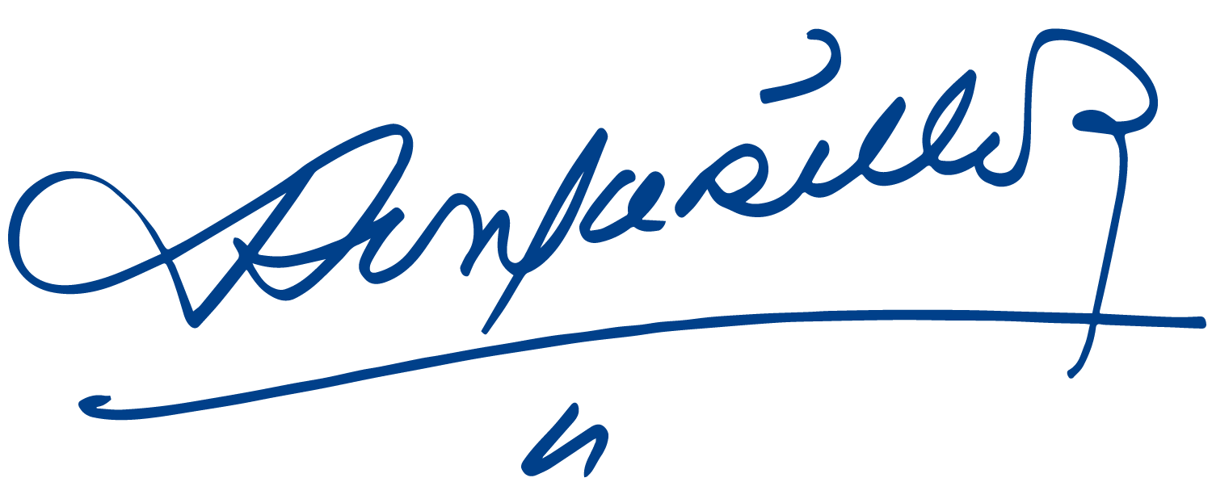
Daniel Ortega Saavedra Rosario Murillo

