Managua, October 31, 2020

Comrade
Roosevelt Skerrit
Prime Minister of the
Commonwealth of Dominica
Roseau

Dear Brother Prime Minister,

On the solemn occasion of commemorating the 42nd Anniversary of Independence of the Commonwealth of Dominica on November 3rd, on behalf of the People and Government of Reconciliation and National Unity of the Republic of Nicaragua, and on our own behalf, we wish express our warmest Congratulations to You and the Brotherly People and Government of Dominica.

Our Nations share a common Caribbean Identity, a profound aspiration toward achieving Well-being and Development and a steadfast commitment to maintaining Our Caribbean America as a Zone of Peace and Prosperity for the Coexistence of our Free and Sovereign Peoples.

Dear Brother Prime Minister,

The Government of Reconciliation and National Unity wishes to reiterate its unwavering resolve toward strengthening the Bonds of Brotherhood, Solidarity and Cooperation that unite our Peoples and Governments.

From our Always Blessed and Always Free Nicaragua, please receive our Fraternal Embrace, as well as the affection of all Nicaraguans for the Brotherly People of Dominica.


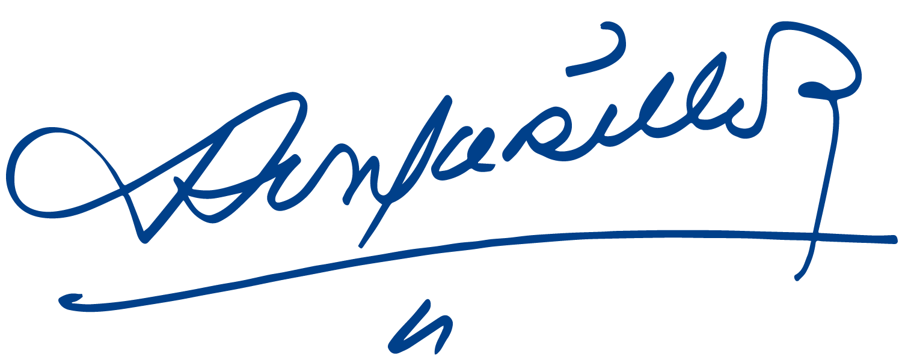
Daniel Ortega Saavedra Rosario Murillo

