Managua, November 16, 2020

His Majesty
Sultan Haitham bin Tariq Al Said
Sultanate of Oman
Muscat

Your Majesty,

On behalf of the People and Government of Reconciliation and National Unity of the Republic of Nicaragua, and on our own behalf, we wish to express our warmest Congratulations to You and the People of the Sultanate of Oman, for commemorating your Independence Day, this upcoming November 18th.

We ask Almighty God to favor your efforts to achieve the aspirations of kindness and prosperity for your People and to bless You with good health and wellbeing on this precious occasion.
Your Majesty,

On this solemn and historic date, the Government of Reconciliation and National Unity of the Republic of Nicaragua wishes to reiterate its will to continue strengthening the Bonds of Fraternity, Solidarity and Cooperation that unite our Peoples, as well as its unwavering commitment to continue working together to overcome the great challenges we face in these difficult times.

From our Always Blessed and Always Free Nicaragua, please receive our Fraternal Embrace and the affection of all Nicaraguans for the Brotherly People of Oman.

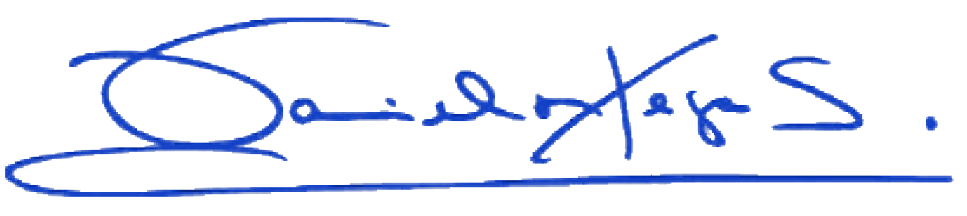
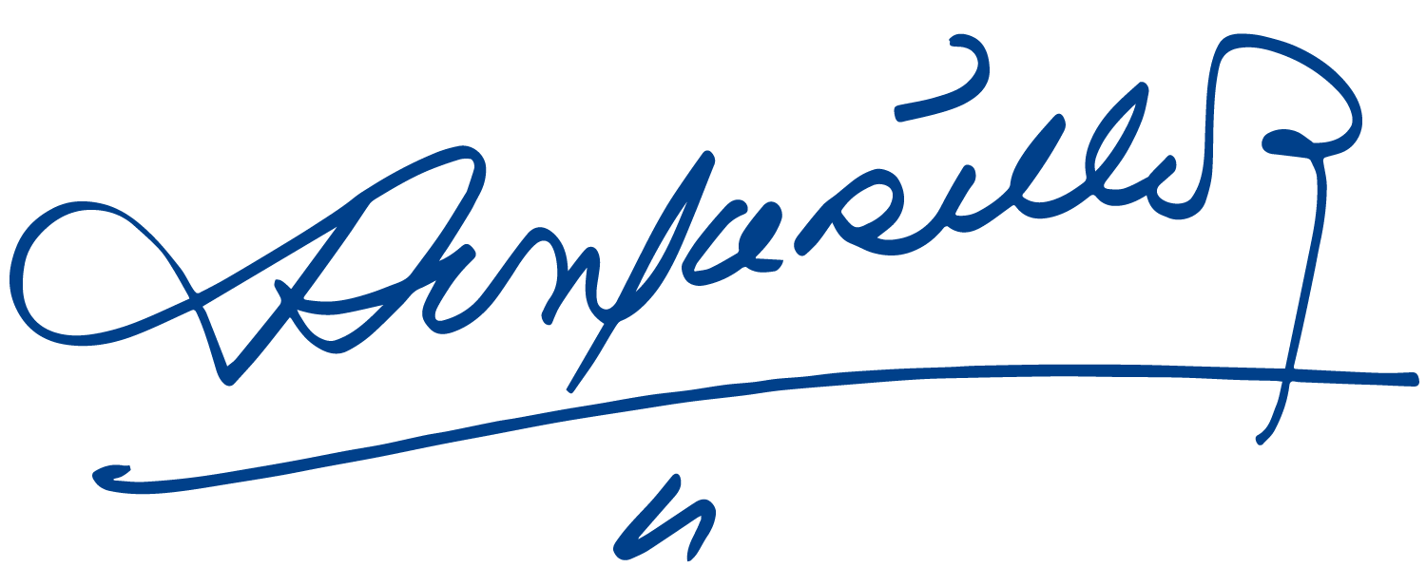
Daniel Ortega Saavedra Rosario Murillo

