December 14, 2020
Managua, Nicaragua

Your Highness
Sheikh Tamim bin Hamad Al-Thani
Emir of the State of Qatar
Doha

Dear Brother, Your Highness:

On behalf of the People and Government of Reconciliation and National Unity of the Republic of Nicaragua, and on our own behalf, we join Your Highness; the Deputy Emir His Highness Sheikh Abdullah bin Hamad bin Khalifa bin Hamad Al-Thani; and the Brotherly People and Government of the State of Qatar in the Commemoration of your National Day on December 18th.

As you commemorate this historic date, we remember one more Anniversary of the Ascension of Sheikh Jassim bin Muhammad Al-Thani, asking for clemency for the soul of the late founder, may God have mercy upon him.

On this special day in which Qatar overflows with Joy, Gratitude and Pride, we ask Almighty God to bless your efforts to achieve the aspirations of more Wisdom, Vision, Kindness, Prosperity, Good Health and Well-being for the Noble Qatari People.

Dear Brother, Your Highness:

The Government of Reconciliation and National Unity of the Republic of Nicaragua wishes to reiterate its will to continue strengthening the Bonds of Solidarity and Cooperation that unite our Peoples and Governments.

From our Always Blessed and Always


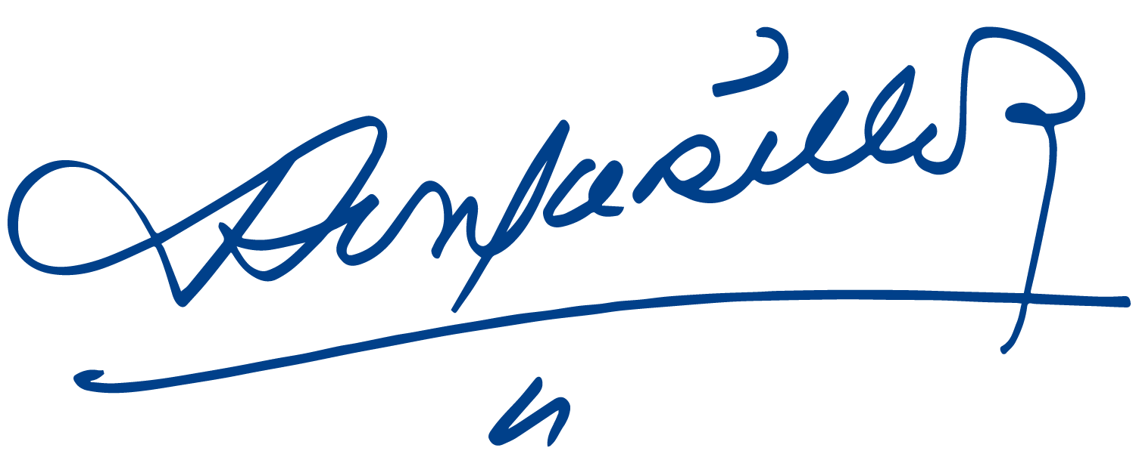
Daniel Ortega Saavedra Rosario Murillo

