Managua, December 2, 2020

Your Excellency
Bounnhang Vorachith
President of the
Lao People's Democratic Republic
Vientiane

Dear Mr. President,

On behalf of the People and Government of Reconciliation and National Unity of the Republic of Nicaragua, and on our own behalf, we wish to express our Congratulations to You, the People and Government of the Lao People's Democratic Republic, on the occasion of commemorating the 45th Anniversary of the Day of the Republic.

Dear President,

The Government of Reconciliation and National Unity of the Republic of Nicaragua wishes to reiterate its will to continue strengthening the Bonds of Fraternity and Solidarity between our Peoples and Governments, as well as its commitment to continue working together to overcome the great challenges that we face in these times.

From our Always Blessed and Always Free Nicaragua, please receive our Fraternal Embrace, as well as the affection of all Nicaraguans for the Brotherly People of Lao.
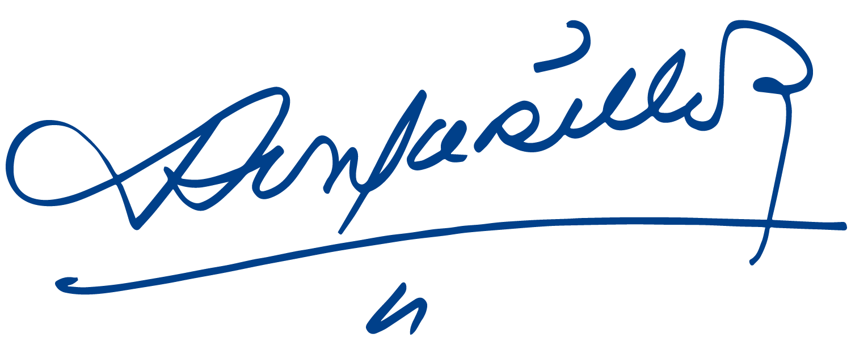
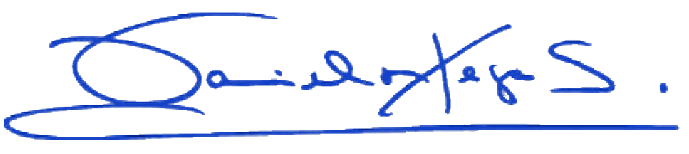

Daniel Ortega Saavedra Rosario Murillo

