Managua, December 2, 2020

Your Highness
Sheikh Khalifa bin Zayed Al-Nahyan
President of the United Arab Emirates
Abu Dhabi

Your Highness,
Dear Brother:

On behalf of the People and Government of Reconciliation and National Unity of the Republic of Nicaragua, and on our own behalf, we extend our sincere expressions of Affection and Friendship to You, the People and the Government of the United Arab Emirates, as you celebrate the 49th Anniversary of the National Day of that Sister Nation.

We also extend our Congratulations to your Brother, His Highness Sheikh Mohammed bin Rashid Al Maktoum, Vice President, Prime Minister and Ruler of Dubai; His Highness Sheikh Mohammed bin Zayed Al Nahyan, Crown Prince of Abu Dhabi and Their Highnesses the members of the Supreme Council of the Union.

We ask Almighty God to bless your efforts to achieve the aspirations of more kindness, prosperity, good health and well-being.

As we remember this solemn date, we pray for mercy for the soul of the late founder of the Emirates, Sheikh Zayed bin Sultan Al Nahyan, may God have mercy on him and the founders of the United Arab Emirates.

Your Highness,

The Government of Reconciliation and National Unity of the Republic of Nicaragua wishes to reiterate its will to continue strengthening the Bonds of Solidarity and Cooperation that unite our Peoples and Governments.

Please receive our Fraternal Embrace from our Always Blessed and Always Free Nicaragua.

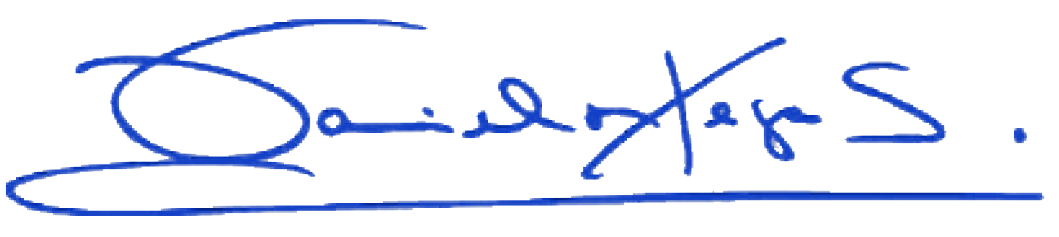
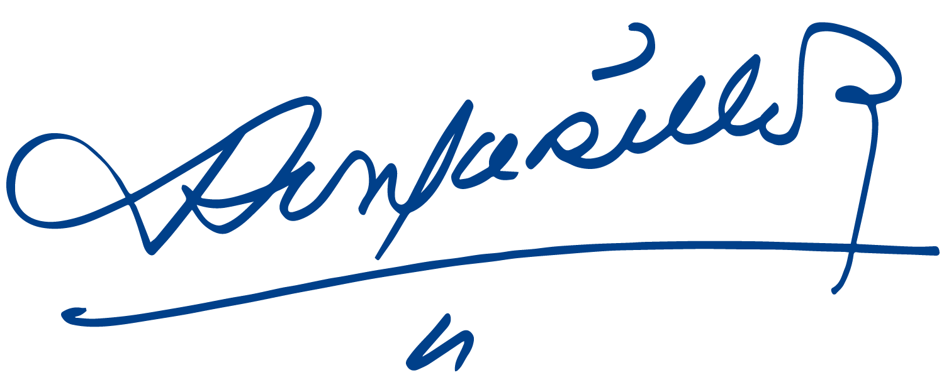
Daniel Ortega Saavedra Rosario Murillo

